**Flaubert, Gustave (1821-1880)**

A primary innovator of the modern novel, French writer Gustave Flaubert was one of the most influential literary artists of the nineteenth century. Primarily associated with REALISM, Flaubert is best remembered for his magnum opus *Madame Bovary* (1857). A close friend of many of his contemporaries including IVAN TURGENEV, HENRY JAMES, and GUY DE MAUPASSANT, Flaubert was one of the moving forces in the early stages of modern literature.

Born in the Northern French city of Rouen in 1821, Flaubert was the second of three children. Flaubert’s father was a surgeon in Rouen. After attending secondary school at Collége Royal de Rouen, Flaubert enrolled in law school in Paris in 1842. He would spend almost two years living in Paris before suffering the first epileptic seizure of his life in January of 1844. As a result, Flaubert’s career as a writer would begin as he moved to a family property in Croisset outside of Rouen. Here Flaubert would write his masterpieces.

**Key Works Published During Lifetime:**

1. *Madame Bovary*
2. *Salammbô*
3. *L’Education sentimentale* [*Sentimental Education*]
4. *La Tentation de Saint Antoine* [*The Temptation of Saint Anthony*]

Despite the fact that Flaubert had began working on *Sentimental Education* wh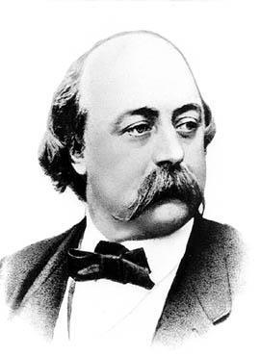ile in Paris and started *The Temptation of Saint Anthony* after seeing Breughel’s painting *Temptation of Saint Anthony* on a trip to Genoa in 1845, his first publication would come with *Madame Bovary* in 1857. The novel focuses on the relationship of Charles and Emma Bovary and Emma’s dissatisfaction with life. Her affair with Rodolphe and her family’s financial troubles lead Emma to commit suicide at the end of the novel. Generally understood as a seminal work in the trajectory of the modern novel, it was widely received and has drawn admirers ranging from Charles Baudelaire to Henry James and Jean-Paul Sartre.

Flaubert’s next work *Salammbô* is a love story and historical account of the siege of Carthage from 240-237 BCE. The next published work by Flaubert, *Sentimental Education*, was also a historical novel. In this work Flaubert covers the period in French history of 1840 to 1851 by illustrating the end of Louis-Philippe’s reign, the revolution of 1848, and the rise of Louis Napoleon. Like *Salammbô,* the novel does not focus solely on the historical context. In *Sentimental Education*, Flaubert describes the life of Frédéric Moreau, a young man from provincial France. Flaubert published the first version of *The Temptation of Saint Anthony* in 1849, the work he considered to be his best. The work focuses on the third-century figure of Saint Anthony and his night of temptation in the Egyptian desert.

Flaubert died of a cerebral hemorrhage at Croisset in 1880 at the age of 58. His legacy remains as one of the true originators of the modern novel as a form and his influence has influenced such literary figures as EMILE ZOLA, FRANZ KAFKA, and Sartre. Perhaps his legacy is best understood through MARCEL PROUST, who referred to Flaubert as a “génie grammatical” (grammatical genius).

-Adam R. McKee

*Picture URL: <http://go.galegroup.com/ps/i.do?id=GALE%7CRN1450000836&v=2.1&u=tall85761&it=r&p=LitRC&sw=w>